**Lab 10**

**Objective:** **To implement preserving user state in distributed applications.**

1. **Create a simple Login Logout and Profile page and use cookie to preserve user state but use MVC Architecture.**

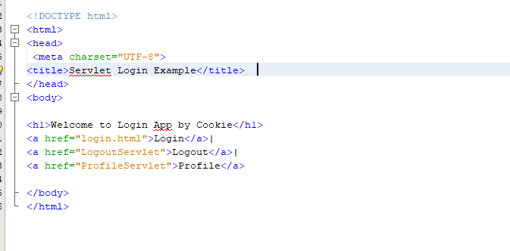

Login

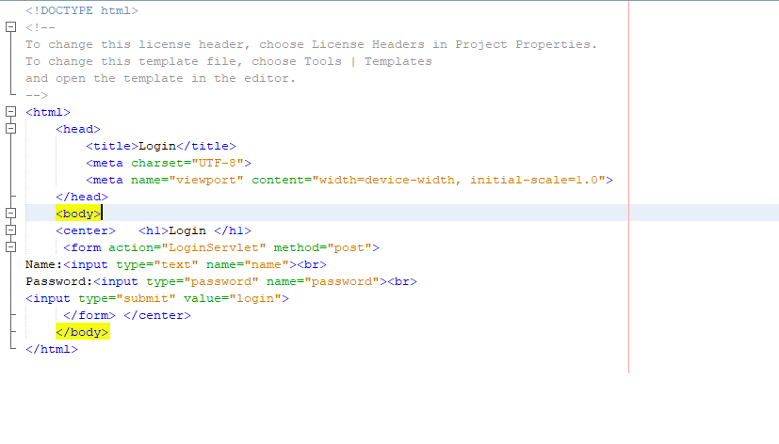

LoginServelet

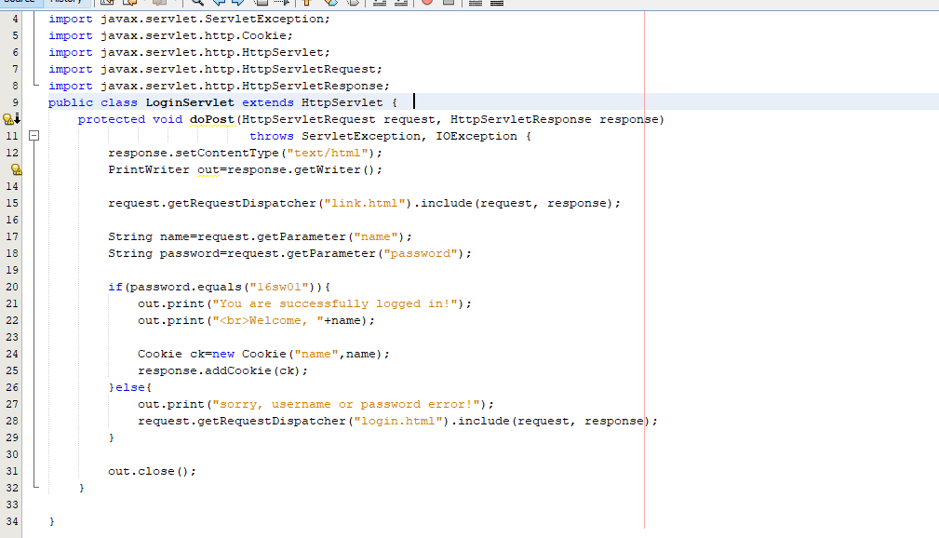

LogoutServelet

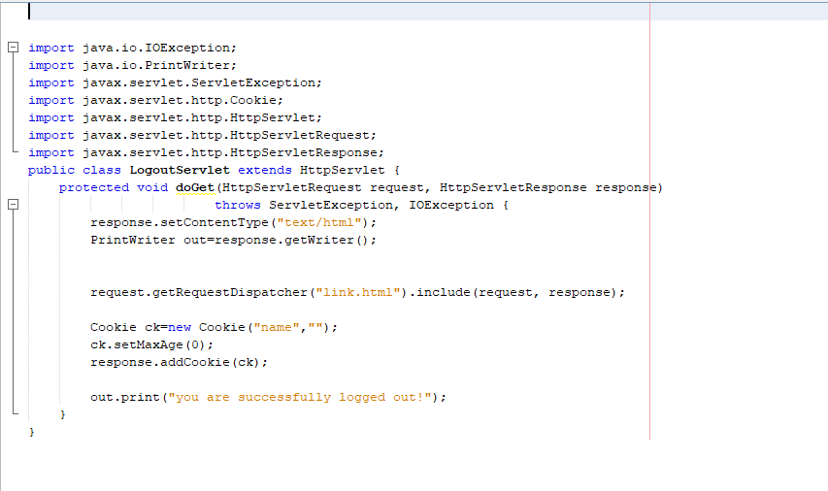

**Output:**

